Produced the input message on Kafka-

JSON-

{"audit":{"createDate":"2021-01-31T06:22:18.004Z","modifiedDate":"2020-11-05T06:25:55.762Z","createdBy":"OSCO-Processor","modifiedBy":"MANHATTAN_FEED"},"orderNumber":"1142020104A","versionNumber":1,"orderStatus":"PAYMENT_REQUESTED","companyId":"1","banner":"carrsqc","isActive":true,"storeNumber":"1739","modifiedReasonCode":"PAYMENT_REQUESTED","orderEditCutoffDate":"2020-11-04T02:00:00.000Z","orderCreatedDate":"2020-11-03T21:02:55.976Z","fulfillmentSystem":"MANHATTAN","sourceInfo":{"source":"ECOMMERCE","enteredBy":"CUSTOMER","deviceType":"WEB"},"orderTotal":{"amount":120.99,"currency":"USD","totalCardSavings":1.5,"cardSavings":[{"savingsCategoryName":"Club Card Savings","savingsAmount":1.5}],"txnLevelSavings":[]},"customer":{"customerId":"557-252-1597270577957","clubCardNumber":"49372835167","isSubscription":false,"name":{"firstName":"Hari","lastName":"Pricing DUG"},"address":[{"addressType":"SHIP-TO","addressLine1":"664 W Evergreen Ave","city":"Palmer","state":"AK","zipCode":"99645","country":"USA"}],"contact":[{"number":"9082557829","type":"MOBILE"}],"email":[{"id":"hgova01@safeway.com","type":"PERSONAL"}],"preference":{"optIn":[{"type":"TEXT","id":"9082557829","isOptin":false}]},"memberId":"903040847964"},"paymentDetails":[{"paymentType":"CREDITCARD","paymentSubType":"MASTERCARD","tokenNumber":"9407672750270035","cardExpiryMonth":"12","cardExpiryYear":"25","zipcode":"19713","reqAuthorizationAmount":"120.99","cardHolderName":"Test Card","address":{"zipCode":"19713"},"paymentStatus":{"status":"NOTAUTHORIZED","authorizationCode":"ET132509","authorizationDate":"2020-11-03T21:02:56.030Z"}},{"paymentType":"CREDITONACCOUNT","paymentSubType":"COA","reqAuthorizationAmount":"2","address":{},"paymentStatus":{"status":"AUTHORIZED","authorizationDate":"2020-11-03T21:02:56.030Z"}}],"exceptions":[{"exceptionCode":"abbbbcc","exceptionDesc":"dsfdg","exceptionType":"hdfed","exceptionTime":"2020-11-03T21:02:56.030Z"}],"subOrders":[{"fulfillmentOrderNumber":"11420201044011","subOrderNumber":1,"fulfillmentType":"DUG","customerService":{"contact":[{"number":"8732748978","type":"PHONE","subType":"DUG_VIRTUAL_PHONE"},{"number":"7983274987","type":"PHONE","subType":"CUST_SERV_PHONE"}]},"deliveryInfo":{"slotInfo":{"slotPlan":"STANDARD","slotType":"ONEHR","slotId":"2042f25c-b774-4f39-b9cc-6760e3ffa27b","timeZone":"America/Anchorage","startTime":"2020-11-05T05:00:00.000Z","endTime":"2020-11-05T06:00:00.000Z","shiftNumber":"3","editingCutoffDate":"2020-11-05T02:00:00.000Z","lastPickupTime":"2020-11-05T05:00:00.000Z"},"instructions":"Test Instructions","pickupInfo":{"locationType":"STORE","locationId":"1739","shortOrderNumber":104},"stageByDateTime":"2020-11-05T06:00:00.000Z"},"charges":[{"id":"0000000029103","name":"BagFee","category":"ServiceFee","chargeAmount":{"amount":0.1,"currency":"USD"}}],"promoCodes":[],"tote":{"toteDetails":[{"toteId":"159002","toteTempZone":"AM"}]},"orderLines":[{"itemId":"108010222","itemDescription":"Coca-Cola Soda Soft Drink, 12 fl oz, 12 Pack","orderedQuantity":3,"shortedQuantity":0,"fulfilledQuantity":3,"unitOfMeasure":"FZ","unitPrice":{"amount":5.99,"currency":"USD"},"substitutionCode":"2","substitutionValue":"Same Brand Diff Size","isRegulatedItem":false,"fulfilledUpc":[{"upcId":"004900002890","upcQuantity":0,"fulfilledQuantity":0,"isSubstituted":false,"upcDescription":"COCA COLA CLASSIC SODA IN FRIDGE PACK","entryId":5005},{"upcId":"004900006721","upcQuantity":3,"fulfilledQuantity":3,"isSubstituted":true,"upcDescription":"COKE MINI CAN CLASSIC","itemPrice":{"itemCode":"0004900006721","entryId":5006,"department":313,"unitPrice":6.99,"extendedPrice":20.97,"quantityType":"EA","quantityValue":3,"discountAllowed":true,"linkPluNumber":"248000183771","itemPluNumber":"0","pointsApplyItem":true,"wic":false,"startDate":"2020-10-06T23:59:00.000Z","endDate":"2020-10-06T23:59:00.000Z","netPromotionAmount":20.97,"savings":[]},"entryId":5006}],"department":{"id":"313","name":"Beverages"},"aisle":{"id":"1_5_7_1","name":"Soft Drinks"},"shelf":{"id":"1_5_7_1","name":"Cola"},"itemPrice":{"itemCode":"0004900002890","entryId":1,"department":313,"unitPrice":5.99,"extendedPrice":17.97,"quantityType":"EA","quantityValue":3,"discountAllowed":true,"itemPluNumber":"0","pointsApplyItem":true,"wic":false,"netPromotionAmount":14.13,"savings":[{"offerId":"619576","externalOfferId":"619576","category":76,"source":"CPE","netPromotionAmount":17.4,"programCode":"SC","startDate":"2020-10-06T00:00:00.000Z","endDate":"2021-11-20T00:00:00.000Z","discountAmount":0.57,"discountType":"Fixed Amount Off","description":"EPE-WYSIWYG-SC-Basket Offer Dollar Off","discountMessage":"","discountLevel":"Basket Level","calculateUsage":false},{"offerId":"619580","externalOfferId":"619580","category":76,"source":"CPE","netPromotionAmount":15.69,"programCode":"SC","startDate":"2020-10-06T00:00:00.000Z","endDate":"2021-11-20T00:00:00.000Z","discountAmount":1.71,"discountType":"Percent Off","description":"EPE-WYSIWYG-SC-Basket Offer Percent Off","discountMessage":"","discountLevel":"Basket Level","calculateUsage":false},{"offerId":"617547","externalOfferId":"1421976126-D","category":69,"source":"CPE","netPromotionAmount":14.13,"programCode":"SC","startDate":"2020-10-06T00:00:00.000Z","endDate":"2022-03-01T00:00:00.000Z","discountAmount":1.56,"discountType":"Percent Off","description":"ADD","discountMessage":"B044","discountLevel":"Basket Level","calculateUsage":false}]}}],"subOrderStatus":"CREATED","modifiedReasonCode":"PAYMENT_REQUESTED"}],"storeInfo":[{"key":"isHybridStore","value":"true"},{"key":"isMFC","value":"false"},{"key":"isErumsEnabled","value":"true"},{"key":"isPremiumStore","value":"true"},{"key":"is3PLStore","value":"true"},{"key":"isDUGArrivalEnabled","value":"false"},{"key":"isWYSIWYGEnabled","value":"true"},{"key":"storeTimeZone","value":"America/Anchorage"},{"key":"terminalNumber","value":"99"},{"key":"DAT_FILE_SENT_BY_VEST","value":"false"},{"key":"SENT_TO_VPOS","value":"Y"}],"orderInfo":{},"id":"5fa39a1ad7d4b5000f5b3c59","version":4,"modifiedBy":"OSCO-Processor","modifiedDate":"2020-11-05T06:25:57.351","ttl":-1}

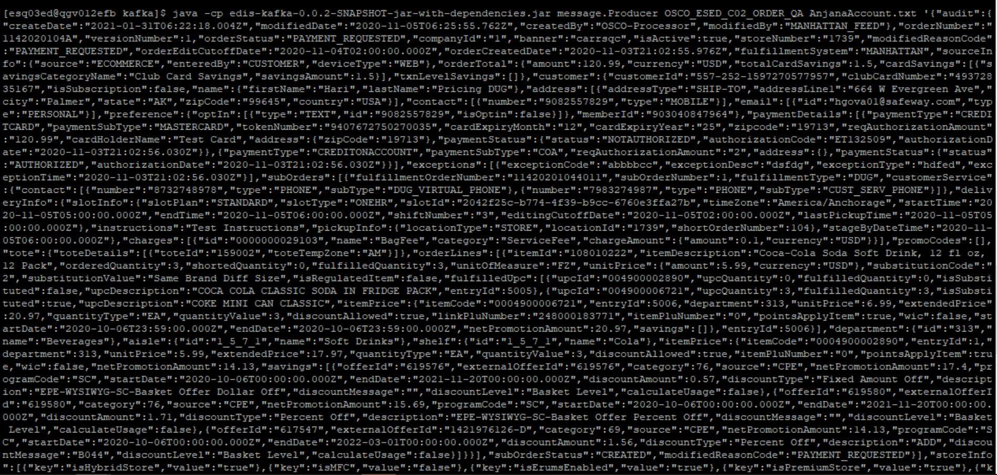

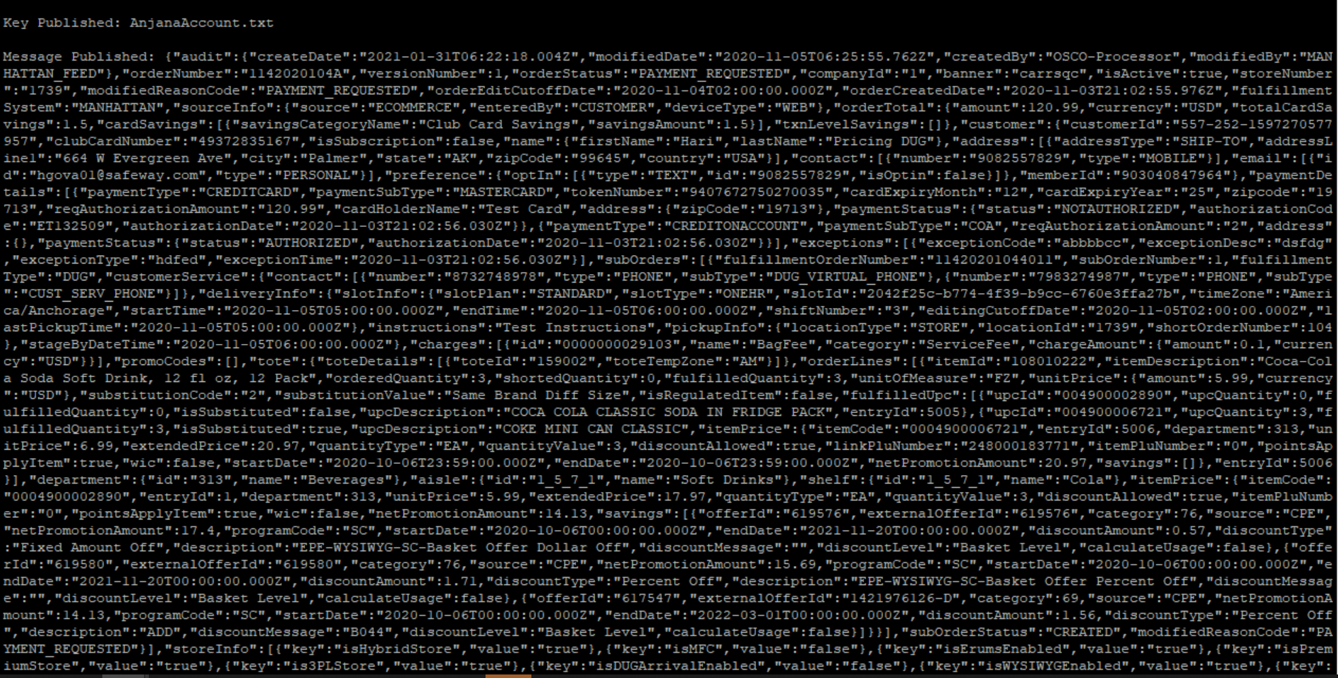

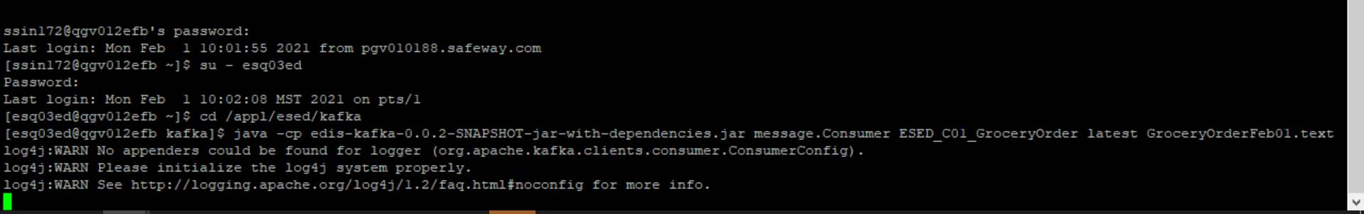

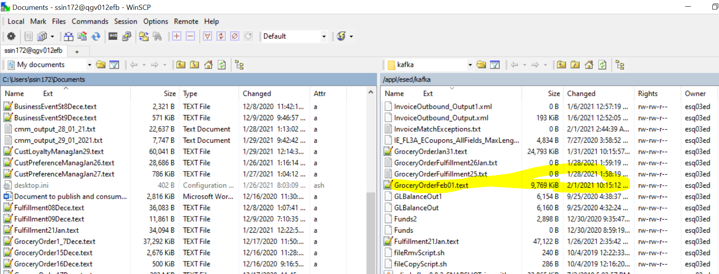

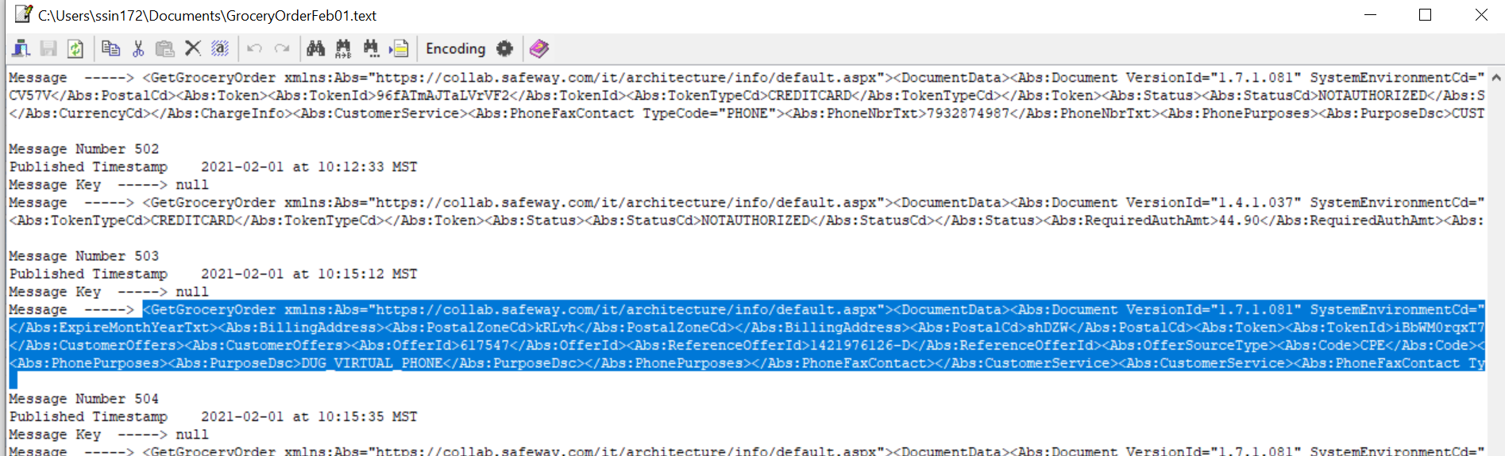

Verify record in Audit table-

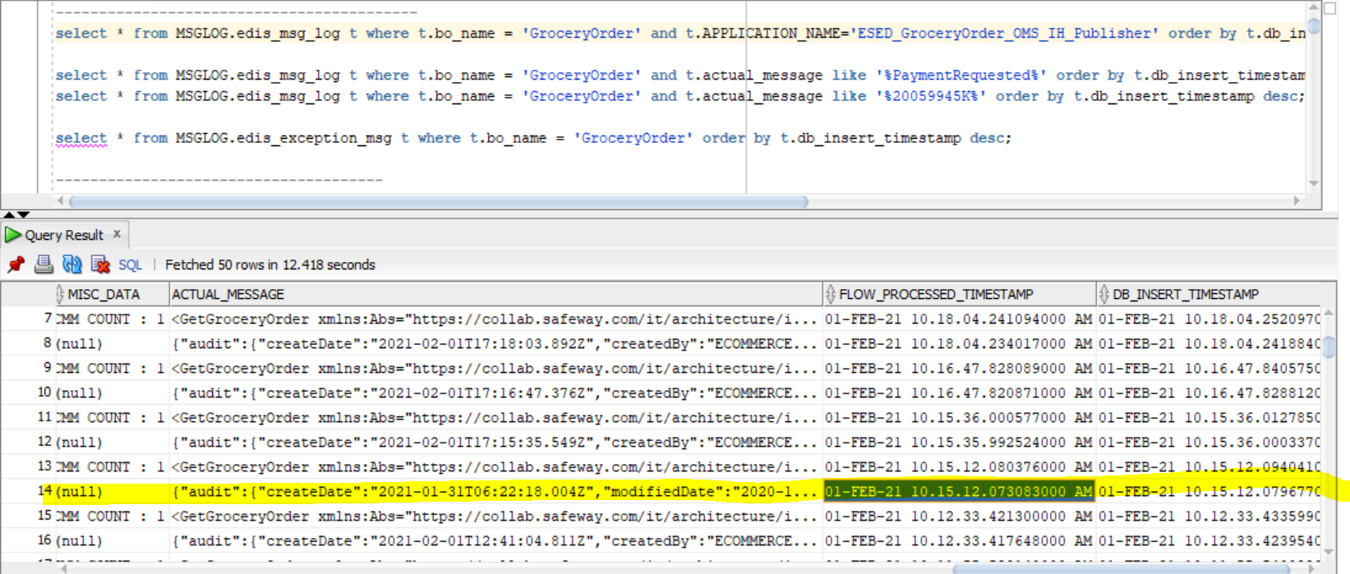

CMM XML-

<GetGroceryOrder

xmlns:Abs="https://collab.safeway.com/it/architecture/info/default.aspx">

<DocumentData>

<Abs:Document VersionId="1.7.1.081" SystemEnvironmentCd="QA">

<Abs:DocumentID>GROCERY_ORDER</Abs:DocumentID>

<Abs:AlternateDocumentID>OSCO_ESED_C02_ORDER-20210201101512075138</Abs:AlternateDocumentID>

<Abs:DocumentNm>GroceryOrder</Abs:DocumentNm>

<Abs:CreationDt>2021-02-01T10:15:12.075138</Abs:CreationDt>

<Abs:Description>GroceryOrderDetail</Abs:Description>

<Abs:SourceApplicationCd>OMS</Abs:SourceApplicationCd>

<Abs:TargetApplicationCd>EDIS</Abs:TargetApplicationCd>

<Abs:SenderId>5fa39a1ad7d4b5000f5b3c59</Abs:SenderId>

<Abs:InternalFileTransferInd>Y</Abs:InternalFileTransferInd>

<Abs:DataClassification>

<Abs:DataClassificationLevel>

<Abs:Code>Internal</Abs:Code>

</Abs:DataClassificationLevel>

<Abs:BusinessSensitivityLevel>

<Abs:Code>Low</Abs:Code>

</Abs:BusinessSensitivityLevel>

<Abs:PHIdataInd>N</Abs:PHIdataInd>

<Abs:PCIdataInd>Y</Abs:PCIdataInd>

<Abs:PIIdataInd>Y</Abs:PIIdataInd>

</Abs:DataClassification>

</Abs:Document>

<Abs:DocumentAction>

<Abs:ActionTypeCd>UPDATE</Abs:ActionTypeCd>

<Abs:RecordTypeCd>CHANGE</Abs:RecordTypeCd>

</Abs:DocumentAction>

</DocumentData>

<GroceryOrderData>

<Abs:GroceryOrderHeader>

<Abs:OrderId>1142020104A</Abs:OrderId>

<Abs:OrderCreateTS>2020-11-03T21:02:55.976Z</Abs:OrderCreateTS>

<Abs:CompanyId>1</Abs:CompanyId>

<Abs:VersionNbr>1</Abs:VersionNbr>

<Abs:OrderStatus>

<Abs:StatusTypeCd>PAYMENT_REQUESTED</Abs:StatusTypeCd>

</Abs:OrderStatus>

<Abs:OrderStatusReasonType/>

<Abs:OrderActionStatus/>

<Abs:EditCutoffDtTm>2020-11-04T02:00:00.000Z</Abs:EditCutoffDtTm>

<Abs:EditReasonType>

<Abs:Code>PAYMENT_REQUESTED</Abs:Code>

</Abs:EditReasonType>

<Abs:FulfillingFacility>

<Abs:RetailStoreId>1739</Abs:RetailStoreId>

<Abs:BannerCd>carrsqc</Abs:BannerCd>

<Abs:HybridStoreInd>Y</Abs:HybridStoreInd>

<Abs:MFCInd>N</Abs:MFCInd>

<Abs:ERUMSEnabledInd>Y</Abs:ERUMSEnabledInd>

<Abs:PremiumStoreInd>Y</Abs:PremiumStoreInd>

<Abs:ThirdPartyDeliveryOnlyInd>Y</Abs:ThirdPartyDeliveryOnlyInd>

</Abs:FulfillingFacility>

<Abs:GroceryOrderProfileType>

<Abs:ProfileType>

<Abs:Code>WYSIWYG</Abs:Code>

</Abs:ProfileType>

<Abs:ProfileValueInd>true</Abs:ProfileValueInd>

</Abs:GroceryOrderProfileType>

<Abs:RetailCustomer>

<Abs:CustomerId>557-252-1597270577957</Abs:CustomerId>

<Abs:CustomerAlternateId Abs:sequenceNbr="903040847964"/>

<Abs:CustomerNm>

<Abs:GivenNm>TDA4</Abs:GivenNm>

<Abs:FamilyNm>Sv9Yovr bUl</Abs:FamilyNm>

</Abs:CustomerNm>

<Abs:Contact>

<Abs:PhoneFaxContact TypeCode="MOBILE">

<Abs:PhoneNbrTxt>g0rNfXM96X</Abs:PhoneNbrTxt>

</Abs:PhoneFaxContact>

</Abs:Contact>

<Abs:Contact>

<Abs:DigitalContact>

<Abs:DigitalAddress>PLeKJJN@2gRVJKa.0xd</Abs:DigitalAddress>

<Abs:EmailStatuses Abs:typeCode="PERSONAL"/>

</Abs:DigitalContact>

</Abs:Contact>

<Abs:Contact>

<Abs:Address>

<Abs:AddressUsageTypeCd>epgj-qg</Abs:AddressUsageTypeCd>

<Abs:AddressLine1txt>2uD C Z9abjDPdu dTT</Abs:AddressLine1txt>

<Abs:CityNm>KBvewj</Abs:CityNm>

<Abs:PostalZoneCd>DPyXG</Abs:PostalZoneCd>

<Abs:StateCd>sWh</Abs:StateCd>

<Abs:CountryCd>USA</Abs:CountryCd>

</Abs:Address>

</Abs:Contact>

<Abs:ClubCardNbr>rKMWs04jSbI</Abs:ClubCardNbr>

<Abs:CustomerSubscription>

<Abs:OptInInd>false</Abs:OptInInd>

</Abs:CustomerSubscription>

</Abs:RetailCustomer>

<Abs:CurrencyCd>USD</Abs:CurrencyCd>

<Abs:TotalAmt>120.99</Abs:TotalAmt>

<Abs:CustomerPayment>

<Abs:Tender>

<Abs:TenderId>iBbWM0rqxT7xPEyl</Abs:TenderId>

<Abs:TenderTypeCd>CREDITCARD</Abs:TenderTypeCd>

<Abs:TenderSubTypeCd>MASTERCARD</Abs:TenderSubTypeCd>

<Abs:HolderNm>snaJ AkKtj</Abs:HolderNm>

<Abs:ExpireMonthYearTxt>B93V</Abs:ExpireMonthYearTxt>

<Abs:BillingAddress>

<Abs:PostalZoneCd>kRLvh</Abs:PostalZoneCd>

</Abs:BillingAddress>

<Abs:PostalCd>shDZW</Abs:PostalCd>

<Abs:Token>

<Abs:TokenId>iBbWM0rqxT7xPEyl</Abs:TokenId>

<Abs:TokenTypeCd>CREDITCARD</Abs:TokenTypeCd>

</Abs:Token>

<Abs:Status>

<Abs:StatusCd>NOTAUTHORIZED</Abs:StatusCd>

</Abs:Status>

<Abs:RequiredAuthAmt>120.99</Abs:RequiredAuthAmt>

<Abs:AuthCd>tnE7SOQt</Abs:AuthCd>

<Abs:AuthDt>2020-11-03T21:02:56.030Z</Abs:AuthDt>

</Abs:Tender>

<Abs:Tender>

<Abs:TenderTypeCd>CREDITONACCOUNT</Abs:TenderTypeCd>

<Abs:TenderSubTypeCd>COA</Abs:TenderSubTypeCd>

<Abs:BillingAddress/>

<Abs:Token>

<Abs:TokenTypeCd>CREDITONACCOUNT</Abs:TokenTypeCd>

</Abs:Token>

<Abs:Status>

<Abs:StatusCd>AUTHORIZED</Abs:StatusCd>

</Abs:Status>

<Abs:RequiredAuthAmt>2.00</Abs:RequiredAuthAmt>

<Abs:AuthDt>2020-11-03T21:02:56.030Z</Abs:AuthDt>

</Abs:Tender>

</Abs:CustomerPayment>

<Abs:CustomerSavings>

<Abs:TotalCustomerSavingsAmt>1.50</Abs:TotalCustomerSavingsAmt>

<Abs:SavingsCategoryType>

<Abs:SavingsCategoryNm>Club Card Savings</Abs:SavingsCategoryNm>

<Abs:SavingsAmt>1.50</Abs:SavingsAmt>

</Abs:SavingsCategoryType>

</Abs:CustomerSavings>

<Abs:OrderRecordDateInfo>

<Abs:CreateDtTm>2021-01-31T06:22:18.004Z</Abs:CreateDtTm>

<Abs:CreateUserId>CUSTOMER</Abs:CreateUserId>

<Abs:UpdateDtTm>2020-11-05T06:25:55.762Z</Abs:UpdateDtTm>

<Abs:UpdateUserId>MANHATTAN_FEED</Abs:UpdateUserId>

</Abs:OrderRecordDateInfo>

<Abs:Device>

<Abs:Code>WEB</Abs:Code>

</Abs:Device>

<Abs:OrderCreatedDeviceType>

<Abs:Code>WEB</Abs:Code>

</Abs:OrderCreatedDeviceType>

<Abs:AffiliatePartnerType/>

<Abs:OrderSourceSystemType>

<Abs:Code>ECOMMERCE</Abs:Code>

</Abs:OrderSourceSystemType>

<Abs:FulFillmentSystemType>

<Abs:Code>MANHATTAN</Abs:Code>

</Abs:FulFillmentSystemType>

<Abs:GroceryOrderHeaderExceptionType>

<Abs:ExceptionType>

<Abs:Code>hdfed</Abs:Code>

</Abs:ExceptionType>

<Abs:ExceptionCd>abbbbcc</Abs:ExceptionCd>

<Abs:ExceptionDsc>dsfdg</Abs:ExceptionDsc>

<Abs:ExceptionCreateTs>2020-11-03T21:02:56.030Z</Abs:ExceptionCreateTs>

</Abs:GroceryOrderHeaderExceptionType>

</Abs:GroceryOrderHeader>

<Abs:GrocerySubOrder>

<Abs:SubOrderNbr>1</Abs:SubOrderNbr>

<Abs:SubOrderStatus>

<Abs:StatusTypeCd>CREATED</Abs:StatusTypeCd>

</Abs:SubOrderStatus>

<Abs:StatusReasonType/>

<Abs:SubOrderActionStatus/>

<Abs:SubOrderServiceLevelType/>

<Abs:GroceryOrderDetail>

<Abs:CartLineNbr>1</Abs:CartLineNbr>

<Abs:ItemId>

<Abs:SystemSpecificItemId>108010222</Abs:SystemSpecificItemId>

<Abs:InternalItemId>0004900002890</Abs:InternalItemId>

<Abs:BaseProductNbr>108010222</Abs:BaseProductNbr>

<Abs:PLUCd>0</Abs:PLUCd>

<Abs:ItemDescription>Coca-Cola Soda Soft Drink, 12 fl oz, 12 Pack</Abs:ItemDescription>

</Abs:ItemId>

<Abs:UnitPriceAmt>5.9900</Abs:UnitPriceAmt>

<Abs:ExtendedUnitPriceAmt>17.9700</Abs:ExtendedUnitPriceAmt>

<Abs:Quantity>3.0000</Abs:Quantity>

<Abs:UOM>

<Abs:UOMCd>FZ</Abs:UOMCd>

</Abs:UOM>

<Abs:DiscountAllowedInd>true</Abs:DiscountAllowedInd>

<Abs:RewardAllowedInd>true</Abs:RewardAllowedInd>

<Abs:SubstitutionType>

<Abs:Code>2</Abs:Code>

<Abs:Description>Same Brand Diff Size</Abs:Description>

</Abs:SubstitutionType>

<Abs:CurrencyCd>USD</Abs:CurrencyCd>

<Abs:RegulatedItemInd>false</Abs:RegulatedItemInd>

<Abs:CouponPLUNbr>0</Abs:CouponPLUNbr>

<Abs:CustomerOffers>

<Abs:OfferId>619576</Abs:OfferId>

<Abs:ReferenceOfferId>619576</Abs:ReferenceOfferId>

<Abs:OfferSourceType>

<Abs:Code>CPE</Abs:Code>

</Abs:OfferSourceType>

</Abs:CustomerOffers>

<Abs:CustomerOffers>

<Abs:OfferId>619580</Abs:OfferId>

<Abs:ReferenceOfferId>619580</Abs:ReferenceOfferId>

<Abs:OfferSourceType>

<Abs:Code>CPE</Abs:Code>

</Abs:OfferSourceType>

</Abs:CustomerOffers>

<Abs:CustomerOffers>

<Abs:OfferId>617547</Abs:OfferId>

<Abs:ReferenceOfferId>1421976126-D</Abs:ReferenceOfferId>

<Abs:OfferSourceType>

<Abs:Code>CPE</Abs:Code>

</Abs:OfferSourceType>

</Abs:CustomerOffers>

<Abs:Department>

<Abs:Code>313</Abs:Code>

</Abs:Department>

<Abs:WICItemInd>false</Abs:WICItemInd>

<Abs:DeliveredItem>

<Abs:FulfillmentOrderId>11420201044011</Abs:FulfillmentOrderId>

<Abs:Item>

<Abs:UPC>

<Abs:UPCNbr>004900002890</Abs:UPCNbr>

</Abs:UPC>

<Abs:SystemSpecificItemId>108010222</Abs:SystemSpecificItemId>

<Abs:BaseProductNbr>108010222</Abs:BaseProductNbr>

</Abs:Item>

<Abs:SubstitutedItemInd>false</Abs:SubstitutedItemInd>

<Abs:Quantity>0</Abs:Quantity>

<Abs:UOM/>

<Abs:RegulatedItemInd>false</Abs:RegulatedItemInd>

<Abs:CustomerSavings/>

</Abs:DeliveredItem>

<Abs:DeliveredItem>

<Abs:DeliveredItemLineNbr>5006</Abs:DeliveredItemLineNbr>

<Abs:FulfillmentOrderId>11420201044011</Abs:FulfillmentOrderId>

<Abs:Item>

<Abs:UPC>

<Abs:UPCNbr>004900006721</Abs:UPCNbr>

</Abs:UPC>

<Abs:SystemSpecificItemId>108010222</Abs:SystemSpecificItemId>

<Abs:InternalItemId>0004900006721</Abs:InternalItemId>

<Abs:PLUCd>0</Abs:PLUCd>

<Abs:BaseProductNbr>108010222</Abs:BaseProductNbr>

</Abs:Item>

<Abs:SubstitutedItemInd>true</Abs:SubstitutedItemInd>

<Abs:Quantity>3</Abs:Quantity>

<Abs:UOM>

<Abs:UOMCd>EA</Abs:UOMCd>

</Abs:UOM>

<Abs:UnitPriceAmt>6.9900</Abs:UnitPriceAmt>

<Abs:ExtendedUnitPriceAmt>20.9700</Abs:ExtendedUnitPriceAmt>

<Abs:PriceEffectiveStartDtTm>2020-10-06T23:59:00.000Z</Abs:PriceEffectiveStartDtTm>

<Abs:PriceEffectiveEndDtTm>2020-10-06T23:59:00.000Z</Abs:PriceEffectiveEndDtTm>

<Abs:RegulatedItemInd>false</Abs:RegulatedItemInd>

<Abs:LinkPLUNbr>248000183771</Abs:LinkPLUNbr>

<Abs:CouponPLUNbr>0</Abs:CouponPLUNbr>

<Abs:PromotionPriceAmt>20.97</Abs:PromotionPriceAmt>

<Abs:RewardAllowedInd>true</Abs:RewardAllowedInd>

<Abs:DiscountAllowedInd>true</Abs:DiscountAllowedInd>

<Abs:WICItemInd>false</Abs:WICItemInd>

<Abs:CustomerSavings/>

</Abs:DeliveredItem>

<Abs:OrderQty>3.0000</Abs:OrderQty>

<Abs:FulfilledQty>3.0000</Abs:FulfilledQty>

<Abs:CustomerSavings/>

</Abs:GroceryOrderDetail>

<Abs:FullFillmentType>

<Abs:Code>DUG</Abs:Code>

</Abs:FullFillmentType>

<Abs:PickupInfo>

<Abs:ShortOrderNbr>104</Abs:ShortOrderNbr>

<Abs:PickupSlot>

<Abs:Code>1739</Abs:Code>

</Abs:PickupSlot>

<Abs:PickupSlotType>

<Abs:Code>STORE</Abs:Code>

</Abs:PickupSlotType>

<Abs:DisplayEndDttm>2020-11-05T05:00:00.000Z</Abs:DisplayEndDttm>

</Abs:PickupInfo>

<Abs:DeliveryInfo>

<Abs:CustomerType/>

<Abs:DeliverySlotId>2042f25c-b774-4f39-b9cc-6760e3ffa27b</Abs:DeliverySlotId>

<Abs:DeliverySlotType>

<Abs:Code>ONEHR</Abs:Code>

</Abs:DeliverySlotType>

<Abs:DeliveryServiceType/>

<Abs:SlotPlan>

<Abs:Code>STANDARD</Abs:Code>

</Abs:SlotPlan>

<Abs:StartDttm>2020-11-05T05:00:00.000Z</Abs:StartDttm>

<Abs:EndDttm>2020-11-05T06:00:00.000Z</Abs:EndDttm>

<Abs:SlotExpiryDttm>2020-11-05T06:00:00.000Z</Abs:SlotExpiryDttm>

<Abs:StageByDttm>2020-11-05T06:00:00.000Z</Abs:StageByDttm>

<Abs:EditCutoffDtTm>2020-11-05T02:00:00.000Z</Abs:EditCutoffDtTm>

<Abs:CustomerInstructionTxt>Test Instructions</Abs:CustomerInstructionTxt>

<Abs:DeliveryTimeZoneCd>America/Anchorage</Abs:DeliveryTimeZoneCd>

</Abs:DeliveryInfo>

<Abs:ChargeInfo>

<Abs:Charge>

<Abs:Code>0000000029103</Abs:Code>

<Abs:Description>BagFee</Abs:Description>

</Abs:Charge>

<Abs:ChargeCategory>

<Abs:Code>ServiceFee</Abs:Code>

</Abs:ChargeCategory>

<Abs:ChargeAmt>0.10</Abs:ChargeAmt>

<Abs:CurrencyCd>USD</Abs:CurrencyCd>

</Abs:ChargeInfo>

<Abs:CustomerService>

<Abs:PhoneFaxContact TypeCode="PHONE">

<Abs:PhoneNbrTxt>8732748978</Abs:PhoneNbrTxt>

<Abs:PhonePurposes>

<Abs:PurposeDsc>DUG_VIRTUAL_PHONE</Abs:PurposeDsc>

</Abs:PhonePurposes>

</Abs:PhoneFaxContact>

</Abs:CustomerService>

<Abs:CustomerService>

<Abs:PhoneFaxContact TypeCode="PHONE">

<Abs:PhoneNbrTxt>7983274987</Abs:PhoneNbrTxt>

<Abs:PhonePurposes>

<Abs:PurposeDsc>CUST_SERV_PHONE</Abs:PurposeDsc>

</Abs:PhonePurposes>

</Abs:PhoneFaxContact>

</Abs:CustomerService>

<Abs:InstructionTxt></Abs:InstructionTxt>

</Abs:GrocerySubOrder>

</GroceryOrderData>

</GetGroceryOrder>